Team Bombastic

Bombastic Bookstore

User manual

Table of Contents

**Introduction**

* 1. **Purpose of this document**
  2. **About the application**

**System Requirements**

**2.1 Hardware**

**2.2 Software**

**Installation Instructions**

**3.1 Navigating the website**

**3.2 Finding and Updating Book Data**

**3.3 User Report and Settigns**

**Troubleshooting**

**5.1 Installation Errors**

**More Help?**

**Introduction**

**Purpose of This Document**

The purpose of this document is to provide a guide in installing this application as well as to offer assistance for problems that occur while implementing and operating the application. In addition, this document provides information on system specification for the application to perform at its best to prevent problems.

**System Requirements**

**Hardware**

An up-to-date desktop or laptop device is needed to run this application. The devices should include the following specifications:

* A secure internet connection
* At least 64 GB of storage
* At least 4 GB of ram
* 1 GHz or faster processor with at least 2 cores

**Software**

The software necessary to run this application will be an up-to-date browser and operating system. This system can run on most browsers and operating systems. However, for the best results use a device with Windows 11 and either Chrome or Microsoft Edge as the internet browser.

**Installation Instructions**

**3.1 Navigating the Application**

**Logging In**

Start by logging into the inventory management system from the login in menu. If you are a first time user, click sign up to create an account to login.

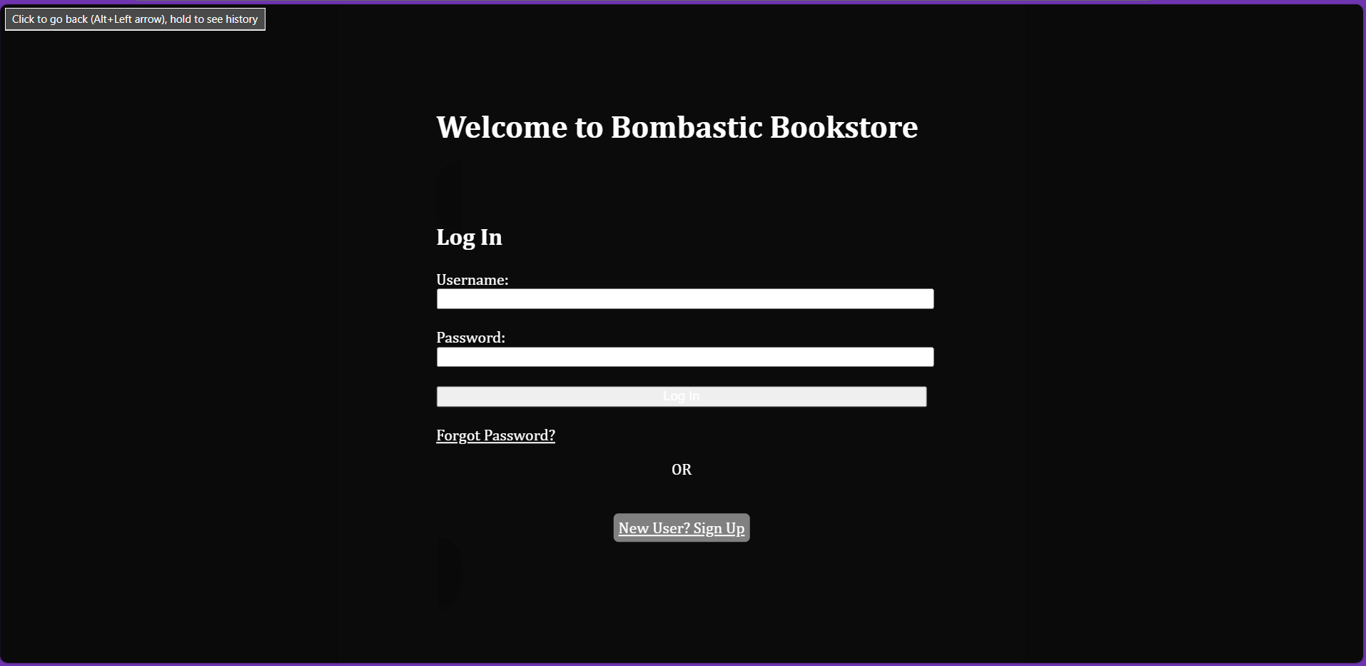

**Exploring the Application**

Use should arrive at the main page of the inventory management system. Here is where you will be able to see the navigation bar with all the tools needed to manage your inventory as well as personalize it.



Let’s start our exploration by adding a book to store.

**Adding Books**

Click on the add items tab on the navigation bar

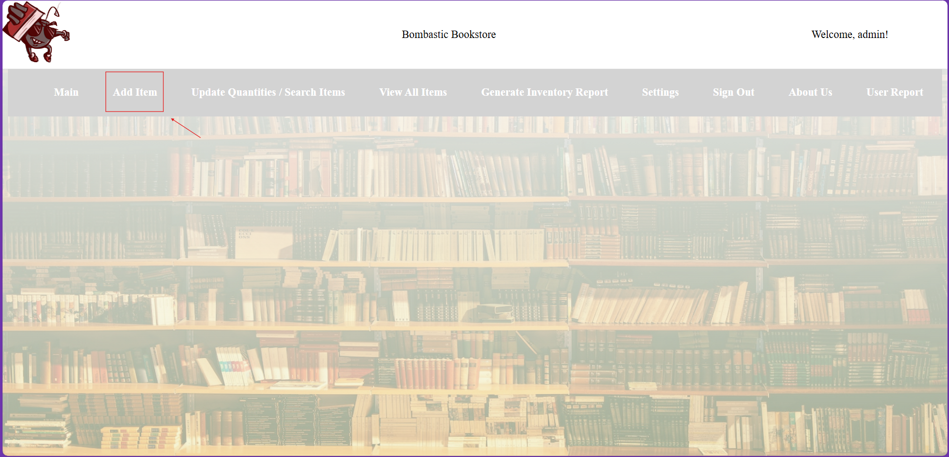

Welcome to the Add Book page here you can add books to store in the management system.

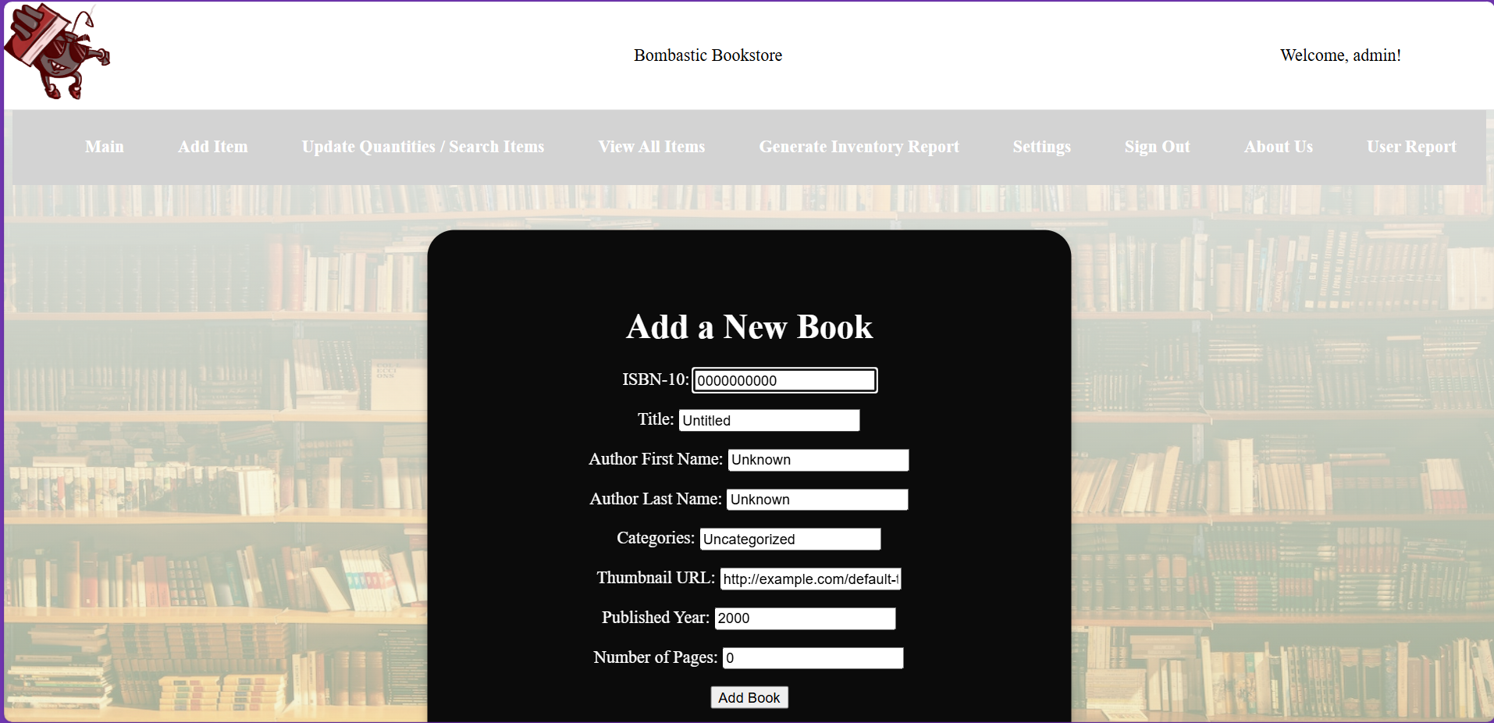

Let’s do a little test run. Add the following book information shown in the image below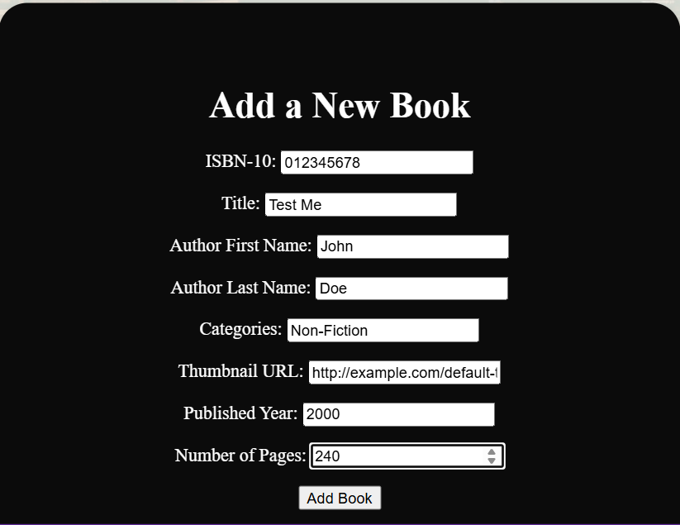

Then press the Add Book button.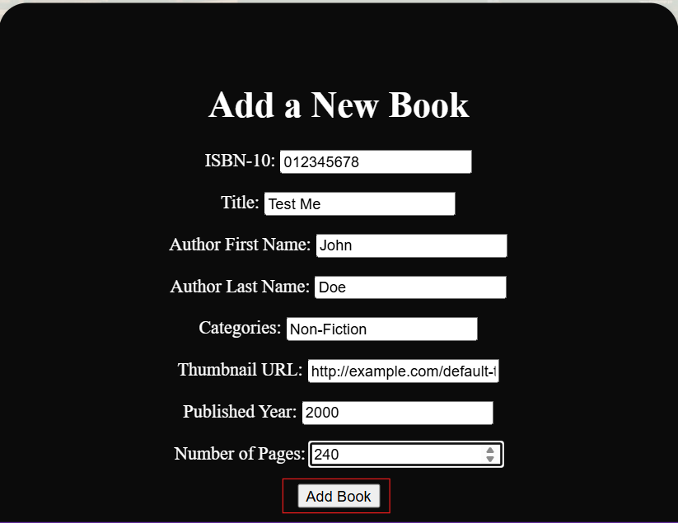

Now let’s see if the book has been successfully added, click the Update Quantities/Search Items Tab.

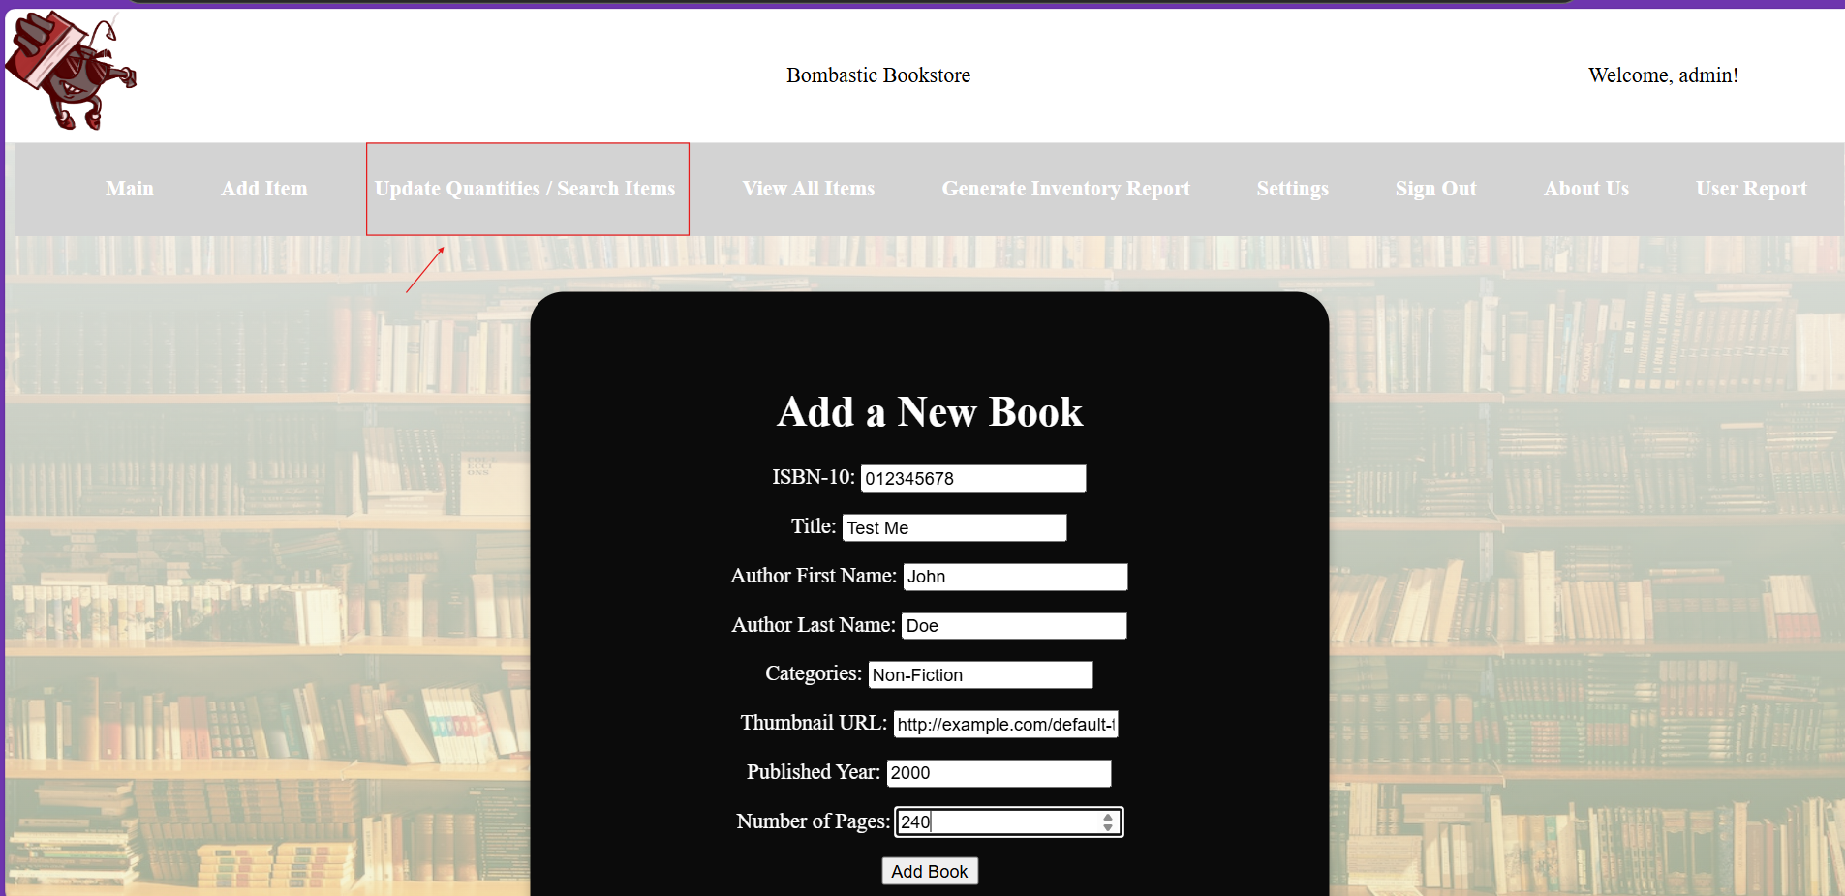

Enter the book title into the search prompt and press the ENTER key.

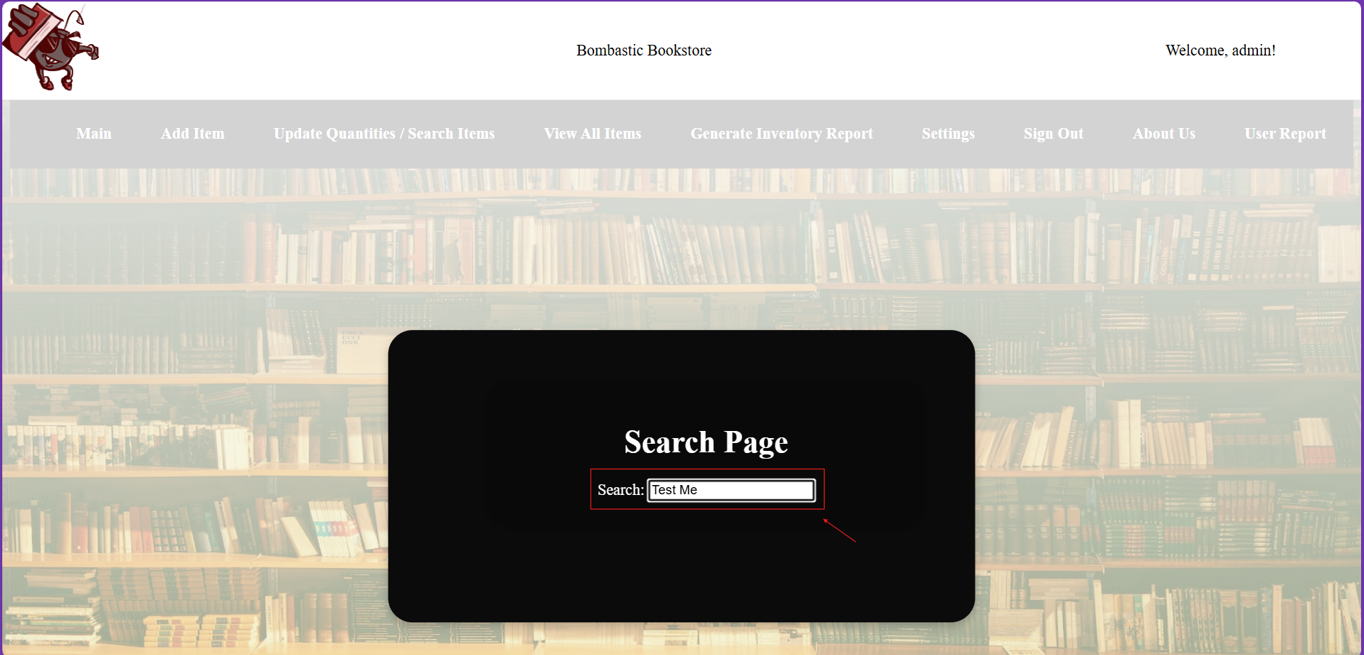

Here we see that our book has been successfully added to the system.

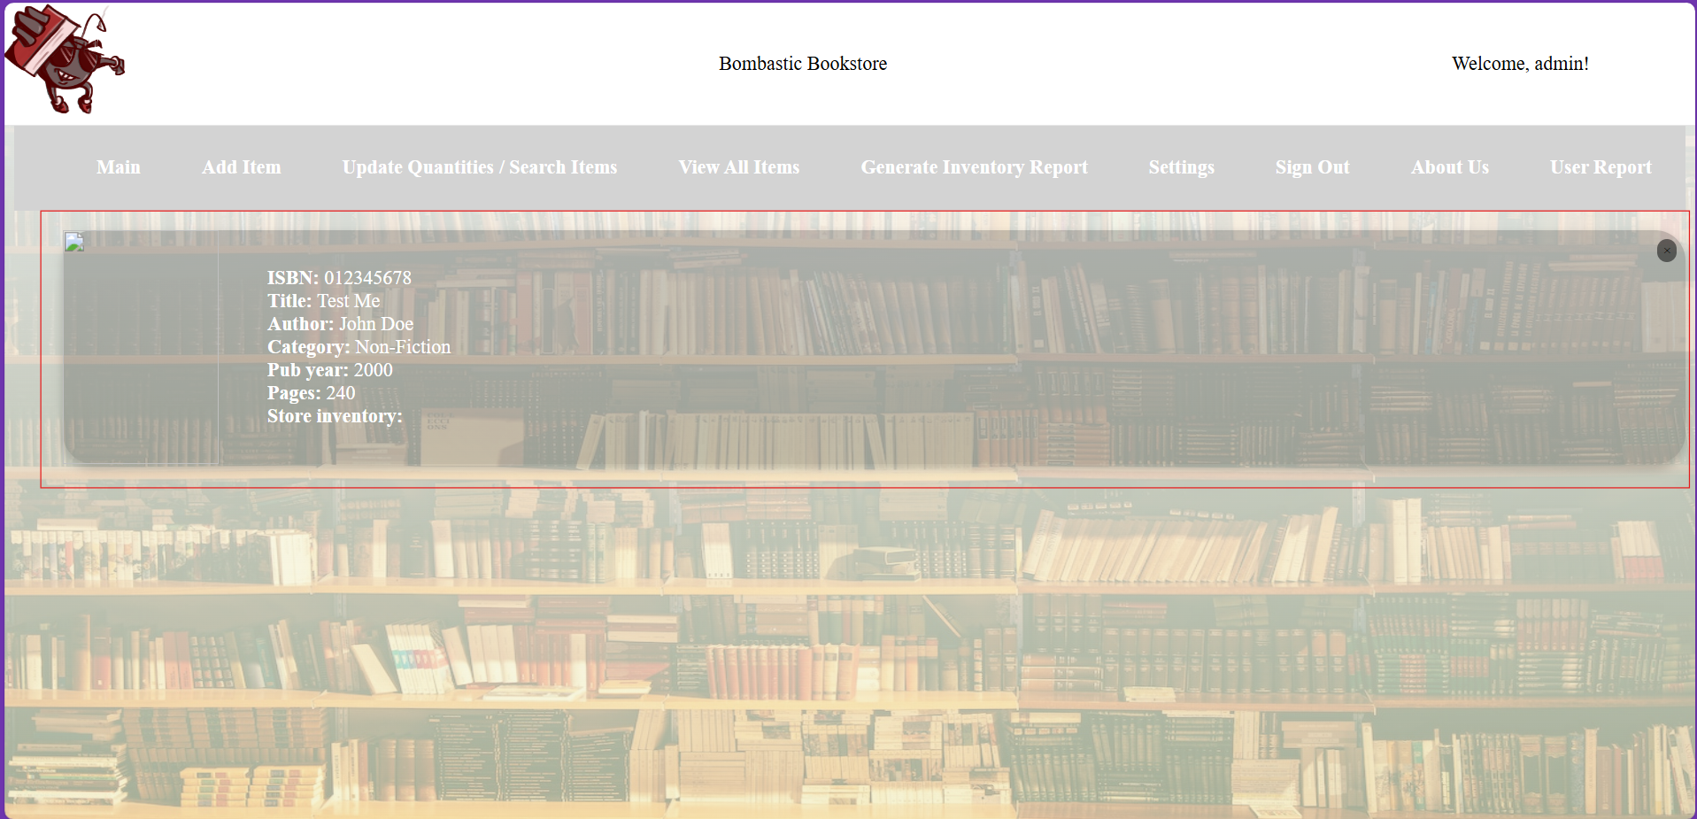

We can also find our book on the View All Items page as well.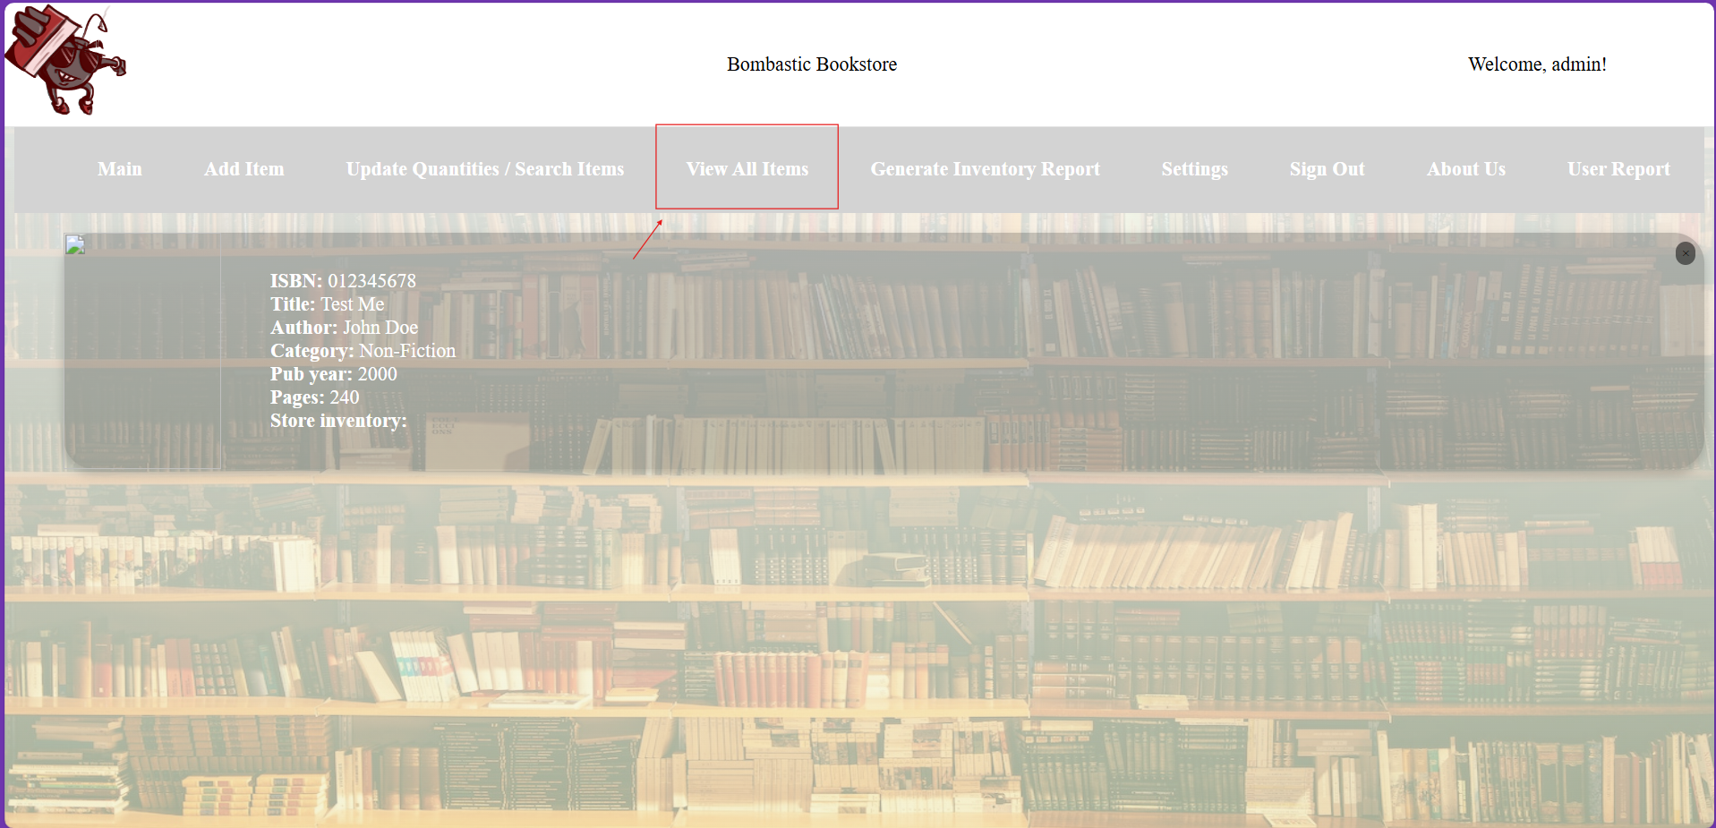

On the View All Items page we can see all the books that are stored in the system.

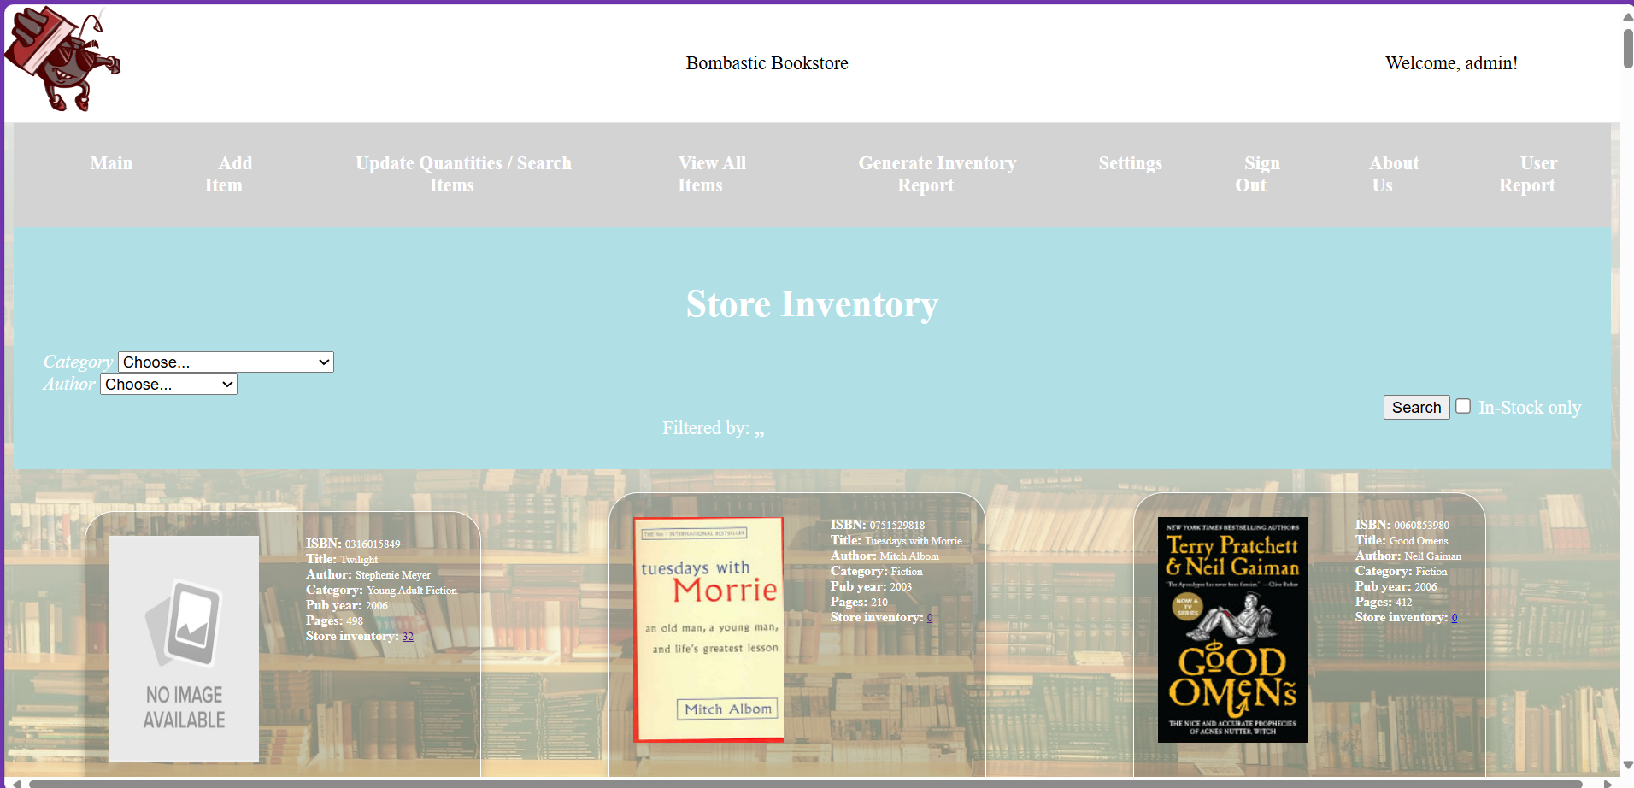

Here we can find our book successfully added as well. 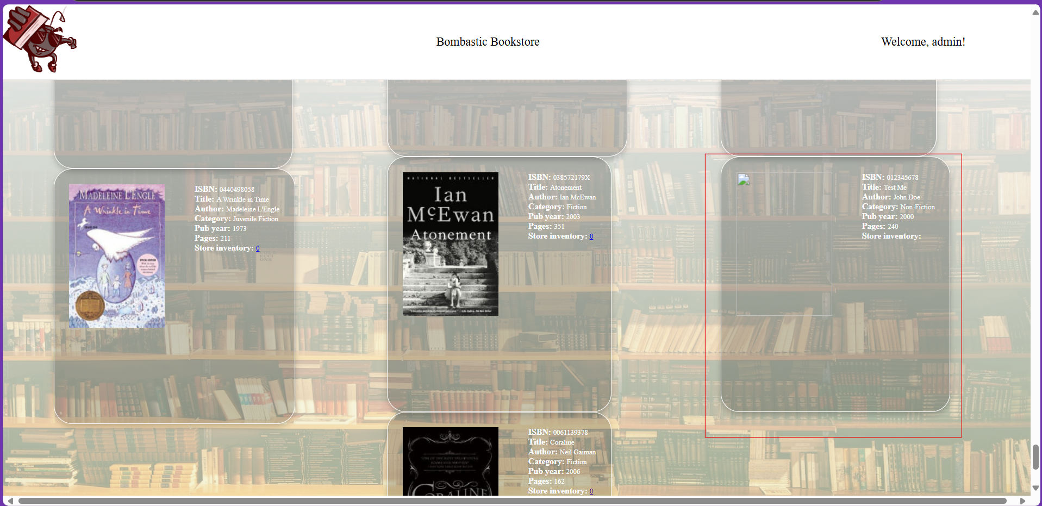

**User Interface Tutorial**

**Troubleshooting**

**More Help?**

If troubleshooting your problem with our user manual has not worked or you have run into bugs we have missed contact our team:

**Email**

[TeamBombastic@gmail.com](mailto:TeamBombastic@gmail.com)

**Phone Number**

**919-866-5000**